When Recorded Return To:

Givens Pursley LLP
Attn: Charlie S. Baser
601 W. Bannock St.
Boise, Idaho 83702

SPACE ABOVE THIS LINE FOR RECORDER’S USE ONLY

LICENSE AGREEMENT

This License Agreement (“Agreement”) is made and entered into as of ___________ ___, 2026 (the “Effective Date”), by and between Ada County Drainage District No. 3, a quasi-municipal corporation organized under the laws of the state of Idaho, Chapter 29, title 42, Idaho Code (“Licensor”), and Veolia Water Idaho, Inc., an Idaho corporation, whose address is 8248 W. Victory Road, Boise, Idaho 83709 (“Licensee”). Licensor and Licensee may each be referred to individually as a “Party” and collectively as the “Parties.”

RECITALS

- Licensor owns and operates Drain A and Drain E located in Ada County, Idaho and approximately depicted on Exhibit A, attached hereto and incorporated herein, and holds one or more easements and/or rights-of-way for the operation and maintenance thereof (collectively, the “Drains”).

- Licensee owns and operates certain well and water tank facilities for water production and storage, as more particularly described and depicted on Exhibit B, attached hereto and incorporated herein (the “Wells”), that discharge water into the Drains at certain discharge locations, as approximately depicted on Exhibit A and described on Exhibit B (the “Discharge Points”). Exhibit A and Exhibit B may be amended from time to time by written agreement of the Parties to reflect Licensee’s abandonment and construction of Wells that discharge to the Drains.

- Licensor desires to grant Licensee a license to encroach on the Drains and discharge water from the Wells into the Drains at the Discharge Points upon the terms and conditions set forth herein.

AGREEMENT

Now, therefore, for good and valuable consideration, the receipt and sufficiency of which are hereby acknowledged, Licensor and Licensee agree as follows:

- Grant of License. Licensor grants Licensee a non-exclusive license (the “License”) (a) to discharge water from the Wells to the Drains at the Discharge Points as provided herein, (b) for Licensee’s equipment and facilities associated with the Wells and Discharge Points (collectively, “Licensee’s Facilities”), as shown on Exhibit B, to encroach into the Drains, and (c) for such access on, over, and across the Drains, and the Drains associated right-of-way and easement, as shown on Exhibit A, as Licensee may reasonably require to construct, operate, maintain, replace, and repair Licensee’s equipment and facilities associated with the Discharge Points, all on the terms and conditions contained herein (the “Purpose”). The Parties acknowledge that the Wells are not located on property owned by Licensor and, to the extent that any authorization or other permission is required by third parties for Licensee to access, operate, maintain, or replace the Wells or facilities associated with the Wells and/or Discharge Points, Licensee will obtain such authorization or permission from such third parties.

- Scope of License.

  - Licensee shall only discharge water to the Drains at the Discharge Points as depicted in Exhibit A and described in Exhibit B. Normal operation flushes (flushes of up to 4 cfs for a period not exceeding 10 minutes per occurrence) from the Discharge Points to the Drains as described in Exhibit B shall not require additional or advance approval from Licensor.

  - Notwithstanding the foregoing, Licensee may conduct long-term flushes from the Discharge Points to the Drains (a “Long-Term Flush”) so long as Licensee submits a request to conduct a Long-Term Flush to Licensor at least thirty (30) days in advance of such Long-Term Flush, which shall be in Licensor’s sole discretion and may be weather and other circumstances dependent. A Long-Term Flush shall be limited to a maximum of 6 cfs for a period of time to be determined by Licensee in its request to Licensor. Licensor and Licensee agree to work around constraints on Long-Term Flushes such as storm events, conflicting discharges, and scheduled maintenance on the Drains.

  - In the event of an emergency affecting the Wells and Licensee’s facilities associated therewith, Licensee may conduct a Long-Term Flush to the Drains (an “Emergency Discharge”) at the Discharge Points without prior notice to or consent of Licensor. Licensee shall notify Licensor within 24 hours of the occurrence of an Emergency Discharge. Should any damage or improvement to the Drains be needed following any such Flush, Licensee shall be solely responsible for remedying such damage or making such improvement, as deemed necessary by Licensor, and shall be at Licensee’s sole cost and expense.

  - Any and all discharges to the Drains made pursuant to this Agreement shall be in compliance with applicable laws and permits held by Licensee.

  - Licensee shall be solely responsible for constructing, operating, maintaining, and replacing Licensee’s Facilities and for all costs and expenses associated therewith. Licensee’s construction, operation, maintenance, and removal of Licensee’s Facilities shall not interfere with Licensor’s use of the Drains except as otherwise provided herein.

  - In furtherance of the Purpose, Licensee shall have the right to trim or remove bushes, trees, undergrowth, and other obstructions located in the Drain around the Discharge Points, but only to the extent necessary to exercise Licensee’s rights hereunder, provided, however, Licensee will use reasonable efforts to limit damage to mature trees and other major landscaping in and around the Discharge Points. Upon commencement of maintenance, repair, or construction activities associated with the Discharge Points, Licensee will diligently perform the activities until completion thereof. Upon completion of the activities, Licensee will diligently restore any damage to the affected areas such that they are substantially returned to their prior condition.

- Licensor’s Responsibilities. In the event of an emergency or a storm event, as determined by Licensor in Licensor’s discretion, and upon notice to Licensee, Licensor may require Licensee to temporarily suspend Licensee’s discharge of water at one or more Discharge Points . When the emergency or storm event subsides, Licensor shall promptly provide notice of the same to Licensee and, upon receipt of such notice, Licensee’s discharges to the Drains at the Discharge Points under this Agreement may immediately resume.

- Amendments to Exhibits.

  - Licensor understands that Licensee’s business operations may require that Licensee abandon or construct New Wells and/or Discharge Points and that Exhibits A and B will need to be amended to reflect such changes. The Parties agree that Licensee may add Discharge Points to Exhibits A and B upon Licensor’s prior written consent, which consent shall not be unreasonably withheld, conditioned, or delayed. Promptly after such consent is granted, the Parties agree to amend this Agreement accordingly and record such amendment in the real property records of Ada County, Idaho.

  - Without limiting the foregoing, as of the Effective Date, the Parties agree that, once Licensee’s construction as described below is completed, Exhibit A and Exhibit B will be updated to reflect the following changes:

    - Chamberlain Wells. Licensee intends to abandon two Wells located in Manitou Park in Boise, which are described as the “Chamberlain Wells” on Exhibit B. Licensee intends to drill and develop a single well to replace the current Chamberlain Wells and add a new Discharge Point adjacent to the existing Discharge Point for the Chamberlain Wells. Licensee shall notify Licensor thirty (30) days in advance of discharging from the new Chamberlain Well.

    - Federal Well. Licensee intends to develop a new Well near the intersection of Federal Ave. and W. Latimer Street in Boise, which will use the same Discharge Point that is currently used by Licensee as described in Exhibit B. Licensee shall notify Licensor thirty (30) days in advance of discharging from the new Federal Well.

  - Prior to the commencement of the construction of any new Discharge Point(s), Licensee shall notify Licensor of the anticipated start date for such construction. Upon completion of such construction, Licensee shall cause any portion of Licensor’s property that was disturbed by Licensee’s construction to be restored to a condition as close as reasonably possible to the condition existing immediately prior to the commencement of the construction. Licensee is solely responsible for obtaining all necessary governmental permits and approvals that may be required for any such construction. Licensee shall restore all abandoned Well property and Discharge Points to a condition as close as reasonably possible to the condition existing immediately prior to use of said Discharge Point.

- Duration and Binding Effect. The License granted herein shall be effective as of the Effective Date and shall remain in full force and effect until the Parties record a duly executed and notarized instrument in the real property records of Ada County, Idaho, terminating the License and the Agreement, and, upon such recording, the Parties shall be relieved of all obligations under the Agreement. Provided, the Licensor may terminate this License at any time for any reason, should it determine in its sole discretion that allowing Licensee to discharge into the Drains is not in the best interest of Licensor. Upon termination, Licensee shall cease any and all use of the Discharge Points and neither Party shall have any further rights or obligations under the License or this Agreement.

- Representations and Warranties. Licensee represents and warrants that it shall maintain the Drainage Points in such a manner as to not damage or harm the Licensor’s Drains and will employee best efforts to improve the area of the Discharge Points so as to help facilitate the proper operation of the Licensor’s Drains.

- Indemnification. Licensee hereby agrees to release, indemnify, defend, and hold Licensor and Licensor’s employees, agents, representatives, successors, and assigns harmless from any claims, liability, losses, costs, charges, debts, obligations, demands, or expenses (including reasonable attorneys’ fees and litigation expenses) arising out of or resulting from the Licensee’s use of License and the Discharge Points, but only to the extent that such matters do not result from the negligence or intentional misconduct of Licensor or its employees, agents, representatives, contractors, or invitees.

- Insurance Requirements. Upon execution of this Agreement and prior to commencing any activities under this Agreement, Licensee shall obtain at its sole cost and expense and thereafter maintain, for the duration of the Agreement, at least the minimum insurance coverages set forth below:

  - Worker’s compensation insurance and Employer’s liability insurance as required by applicable law or regulation;

  - Commercial general liability insurance covering all operations by or on behalf of the Licensee with minimum limits of liability of $1,000,000 for each occurrence and $5,000,000 aggregate for both bodily injury and property damage. The commercial general liability insurance policy shall name Licensor as Additional Insured and shall protect its officers, agents and employees from and against any and all claims, losses, actions, and judgments for damages or injury to persons or property arising out of or in connection with Lisencee’s negligence during the performance of this Agreement; and

  - Automobile liability insurance including coverage for owned, hired, and non-owned automobiles. The limits of liability shall not be less than $1,000,000 combined single limit each accident for bodily injury and property damage combined.

- Recordation. This Agreement shall be recorded in the real property records of Ada County, Idaho.

- Assignment. Licensee shall have the right to assign this Agreement and the License granted herein to a third party upon sixty (60) days’ written notice to Licensor, provided that the assignee shall agree to comply with all applicable terms and conditions of this Agreement and assume all of Licensee’s obligations hereunder. Approval of such assignment shall be in the sole discretion of Licensor and shall require Licensor’s written consent. In the event of such an assignment, Licensee shall provide Licensor with the name and contact information of the proposed assignee and the effective date of the assignment.

- Attorneys’ Fees. If any controversy, claim, or action is filed or instituted to enforce the terms and conditions of this Agreement or arises from the breach of any provision hereof, the prevailing Party shall be entitled to receive from the other Party all costs, damages, and expenses, including reasonable attorneys’ fees, incurred by the prevailing Party.

- Notice. All notices required hereunder shall be given in writing and shall be deemed properly served or delivered to the Parties at the addresses set forth below or at other such addresses as may be specified from time to time: (a) if delivered in person, upon delivery; (b) if deposited for overnight delivery with any reputable overnight courier service, delivery confirmation requested, one (1) day after being deposited; (c) if sent via the U.S. Postal Service, registered or certified mail, five (5) days after being deposited with sufficient postage; or (d) if sent by electronic mail, upon transmission.

- General. This Agreement is the entire agreement between the Parties with respect to the matters covered hereby and supersedes all prior agreements between them, written or oral. All Recitals and Exhibits to this Agreement are hereby incorporated by reference as if set forth herein. The Parties agree that the facts set forth in the Recitals above are true and correct. However, in the event of a conflict between such Recitals and the terms of this Agreement, the terms of this Agreement shall control. Any reference to “including” will be construed to include “but not limited to.” This Agreement may be executed in counterparts, each of which is deemed an original but all of which constitute one and the same instrument; the signature pages may be detached from each counterpart and combined into one instrument. This Agreement may be amended only by written agreement executed by both Parties. No waiver of any right or remedy in the event of default hereunder shall constitute a waiver of such right or remedy in the event of any subsequent default. The laws of the State of Idaho shall govern this Agreement. The invalidity or unenforceability of any provision of this Agreement shall not affect the validity or enforceability of any other provision hereof. The headings of the several sections contained herein are for convenience only and do not explain, define, limit, amplify, or aid in the interpretation, construction, or meaning of the provisions of this Agreement.

[Remainder of page intentionally blank; signature page follows]

IN WITNESS WHEREOF, the Parties have executed the Agreement as of the Effective Date.

LICENSOR:

Drainage District #3,
an Idaho Drainage District located in Ada County

By: __________________________
Name: ________________________
Its: ___________________________

Address for notices:
_________________________
_________________________
_________________________
Email: ___________________

With copy to:
Abigail Germaine
Elam & Burke
251 E. Front St., Suite 300
Boise, Idaho 83702
Email: arg@elamburke.com
STATE OF IDAHO )
) ss.
County of Ada )

This record was acknowledged before me on this ___ day of _____________________, 2026, by ________________________________, acting as ________________________ for Ada County Drainage District No. 3.

My Commission Expires

LICENSEE: Veolia Water Idaho, Inc.,
an Idaho corporation

By:
Name:
Its:

Address for notices:
Veolia Water Idaho, Inc.
Attn: Director of Engineering
8248 W. Victory Road
Boise, Idaho 83709
Email: catherine.cooper@veolia.com

With copy to:
Charlie S. Baser
Givens Pursley LLP
601 W. Bannock St.
Boise, Idaho 83702
Email: charliebaser@givenspursley.com

STATE OF IDAHO )
) ss.
County of Ada )

This record was acknowledged before me on this ___ day of _____________________, 2026, by ________________________________, acting as ________________________ for Veolia Water Idaho, Inc.

My Commission Expires

EXHIBIT A
Depiction of Drains and Discharge Points

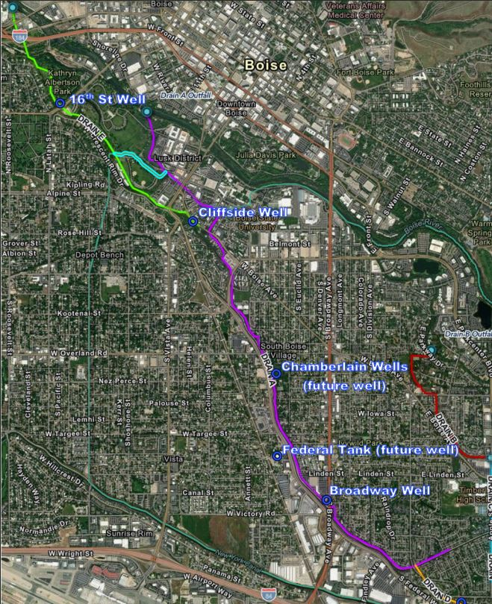

EXHIBIT B
Description of Wells, Discharge Points, and flushes

Well | Discharge Point Drain | Well and Discharge Point Locations | Details
16th Street Well | Pond connected to Drain E | Kathryn Albertson Park | Well flushes into a pond connected to Drain E. This Well typically runs daily to meet peak demands. Long term flushes currently coordinated with park manager.
Broadway Well | Drain A | S. Broadway Avenue in Boise near Shopco
Chamberlain Wells (Wells 1 & 2)  (New Chamberlain Well (Well 3)) | Drain A | Manitou Park | Licensee plans to abandon Wells #1 & #2 and drill and develop Well #3 as a new consolidated Well with a new discharge point adjacent to the location of the existing discharge point.
Cliffside Well | Drain A | W. Boise Ave. in Boise near BSU | Flush line runs down Boise Ave. and outfalls to Drain A.
Federal Tank (Future Federal Well) | Drain A | W. Latimer Street, Boise, near the intersection of Federal Ave. | Licensee plans to develop a new Well at this site in 2025/2026. The new Well will discharge into the existing flush line that discharges into Drain A.

4922-4363-5870, v. 2

