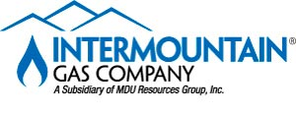

WESTERN REGION OFFICE
555 SOUTH COLE ROAD • BOISE, ID. 83709
(208) 377-6000 • Fax (208) 377-6867
www.intgas.com

June 26, 2024

Elam and Burke Attorneys at Law
Attn: Abigail R. Germaine
251 E Front St. Suite 300
Boise, Idaho 83702

Dear Abigail,

Intermountain Gas Company is proposing a new crossing of the Bubb Canal in Boise, Idaho and is requesting to bore approximately 10’ under the ditch north of Martha St on Chrisway Dr.

Intermountain Gas would like your permission to replace a portion of our 2” Steel gas main that runs North to South on the West side of Chrisway Dr. and currently does cross the Bubb Canal. Intermountain Gas will be representing Dasco of Idaho that will be adding the new gas 2” line by boring under the Bubb Canal in the area stated above. Construction is planned to start in the fall after the permit has been approved by the irrigation district. For more information, please refer to the attached drawing of the proposed canal crossing.

If you have any questions, please call Tonia Kingston at (208) 377-6866 or email Tonia.Kingston@intgas.com. Thank you for your time and consideration in this matter.

Sincerely,

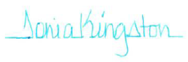
Tonia Kingston
Energy Services Technician

CC: Nick Kraus

